Epsom & Ewell F.C.
3
v
Cove
Saturday, 8th September 2018 – 3.00 p.m.
Good afternoon and welcome to High Road for our first Saturday home match of the season. We welcome the players, supporters and officials of Cove after an absence of two seasons.

We last met our opponents in March of 2016 when they were having an awful season that ended in relegation. Having said that we required an injury time winner from Matt Farrell to edge the win by the only goal at High Road that evening. Of course we have now joined them at Step Six and meet in a third different league Division, following our meetings in the nineties in Isthmian League competition when we competed in Division Three.

Our last appearance here was eleven days ago at home to Beckenham Town, who were deserving of the 3-0 win on the night, although we made them work for it by taking them to extra time. Unfortunately we followed this with a trip to Whyteleafe on the Friday where we met Lingfield in the F.A. Vase and were crushed 6-1 to become one of the first teams out of the competition.

This means that we have now played seven matches, winning three, drawing one and losing the other three. Whilst that might look an average record so far, it must be stressed that four of our seven opponents so far this season have been Step Five clubs and it is to be hoped that most of our opponents this season will not be of that standard!

Our programme had to go to print before our League match at AC London on Wednesday and will be reported on in the next issue, although it will be on our website by now. It is to be hoped that we have secured a good result and can take that into today’s match, with another important encounter on Tuesday coming up when we make our first visit to the new Meadowbank for a meeting with Dorking Wanderers Reserves. We then currently have a spare Saturday before returning here for a home match with Tooting Bec on Tuesday 18th September, although we may still have a match on the Saturday. Keep checking the website!

We have two things to commemorate today. The first is our Centenary Evening Dinner this evening at Epsom Golf Club starting at 8pm and the second is that our President Stella Lamont celebrated reaching the grand milestone of her 90th birthday last Saturday. We have an article on our President later on in this issue, who of course also adorns our front cover.

Enjoy the game!

Rich

You can follow us on Facebook: www.facebook.com/epsomandewellfc
Twitter: @EEFCOfficial Instagram at: www.instagram.com/epsomandewellfc
and Youtube at: www.youtube.com/channel/UCtLrpS0x5OaYUACRT34_zng

Today’s cover photos

- Our President Stella Lamont celebrates her 90th birthday last Saturday
- Kyle Hough and Rob Hendry score against Cove in our 7-0 win there on 3rd October 2015

Cherry Red Records Combined Counties League
Division One Table 2018/19
inc Tuesday 4th September 2018 | P | W | D | L | F | A | Pts | GD | H | A
Bedfont & Feltham | 6 | 4 | 2 | 0 | 29 | 4 | 14 | +25 | 8/12 | 13/4
Farnham Town | 6 | 4 | 1 | 1 | 17 | 6 | 13 | +11 | 2/2 | 20/10
Dorking Wanderers Res | 6 | 3 | 3 | 0 | 13 | 7 | 12 | +6 | 27/11 | 11/9
Ash United | 5 | 3 | 2 | 0 | 16 | 7 | 11 | +9 | 12/1 | 10/11
Chessington & Hook Utd | 6 | 3 | 1 | 2 | 13 | 14 | 10 | -1 | 1-2 | 27/10
Sheerwater | 4 | 3 | 0 | 1 | 9 | 5 | 9 | +4 | 6/10 | 22/12
Sandhurst Town | 4 | 3 | 0 | 2 | 6 | 10 | 9 | -4 | 20/4 | 2-0
AC London | 4 | 2 | 1 | 1 | 10 | 8 | 7 | +2 | 2/3 | 5/9
Tooting Bec | 5 | 2 | 1 | 2 | 7 | 7 | 7 | 0 | 18/9 | 30/3
British Airways | 6 | 2 | 1 | 3 | 10 | 15 | 7 | -5 | 16/2 | 13/10
Epsom & Ewell | 3 | 2 | 0 | 1 | 6 | 2 | 6 | +4 | X | X
Frimley Green | 4 | 1 | 3 | 0 | 4 | 3 | 6 | +1 | 3/11 | 23/2
Eversley & California | 4 | 2 | 0 | 2 | 8 | 8 | 6 | 0 | 29/12 | 24/11
FC Deportivo Galicia | 6 | 1 | 2 | 3 | 8 | 7 | 5 | +1 | 12/3 | 22/9
Godalming Town | 5 | 1 | 1 | 3 | 5 | 13 | 4 | -8 | 1/12 | 26/1
Kensington Borough | 5 | 1 | 0 | 4 | 9 | 17 | 3 | -8 | 17/11 | 9/3
Bagshot | 4 | 1 | 0 | 3 | 3 | 19 | 3 | -16 | 19/1 | 3-0
Fleet Spurs | 5 | 0 | 0 | 5 | 5 | 15 | 0 | -10 | 6/4 | 29/9
Cove | 5 | 0 | 0 | 5 | 4 | 15 | 0 | -11 | 8/9 | 5/1

Lucky Day? – 8th September
Played 17 - Won 7 Drawn 3 Lost 7 - For 24 Against 35 - PPG 1.41 - Average
Our Club record against Cove
Played 34 - Won 15 Drawn 9 Lost 10 - For 75 Against 55 - PPG 1.59 - Above Average
Our Largest wins and losses against Cove
3rd October 2015 - W 7-0 - Combined Counties League (A)
27th April 2013 - L 1-6 - Combined Counties League (H)
Cove’s Last Visit
15th March 2016 - Won 1-0 - Combined Counties League Premier Division

First Eleven Appearances 2018/19 - (max 7)
Name | Debut | 2017/18 |  |  |  | Career Totals
 |  | App | Sub | Tot | Goals | App | Sub | Tot | Goals
BENNETT Bobby | 12/08/2018 | 5 | 0 | 5 | 1 | 5 | 0 | 5 | 1
BETANCOURT Steve | 18/08/2018 | 4 | 0 | 4 | 0 | 4 | 0 | 4 | 0
BORRETT Ricky | 04/08/2018 | 5 | 0 | 5 | 0 | 5 | 0 | 5 | 0
CAMPBELL Kieran | 29/09/2012 | 6 | 0 | 6 | 0 | 58 | 0 | 58 | 0
CAMPBELL Theo | 28/08/2018 | 0 | 2 | 2 | 0 | 0 | 2 | 2 | 0
CONNELLY Lloyd | 14/10/2017 | 7 | 0 | 7 | 2 | 37 | 4 | 41 | 4
DOBRAJ Endrit | 18/11/2017 | 1 | 0 | 1 | 0 | 20 | 4 | 24 | 0
DYSON Ben | 12/08/2017 | 0 | 1 | 1 | 0 | 28 | 14 | 42 | 2
ELGAR Luke | 04/08/2018 | 1 | 2 | 3 | 0 | 1 | 2 | 3 | 0
ELGAR Scott | 12/08/2018 | 2 | 4 | 6 | 0 | 2 | 4 | 6 | 0
GILL George | 28/08/2018 | 2 | 0 | 2 | 0 | 2 | 0 | 2 | 0
GRIFFIN Reisse | 08/08/2015 | 4 | 0 | 4 | 1 | 108 | 13 | 121 | 9
HEAGNEY Adam | 16/08/2016 | 7 | 0 | 7 | 0 | 74 | 13 | 87 | 2
JONES David | 31/08/2018 | 0 | 1 | 1 | 0 | 0 | 1 | 1 | 0
LOFTUS-CHEEK Joe | 06/08/2017 | 0 | 1 | 1 | 0 | 15 | 7 | 22 | 6
MCKAY Alex | 20/12/2008 | 1 | 0 | 1 | 0 | 163 | 39 | 202 | 13
MURPHY Scott | 20/01/2007 | 7 | 0 | 7 | 0 | 54 | 2 | 56 | 4
ROBERTS Liam | 12/08/2017 | 6 | 1 | 7 | 3 | 27 | 15 | 42 | 8
SMITH Taryn | 28/10/2017 | 1 | 4 | 5 | 4 | 9 | 8 | 17 | 4
SULLIVAN Ryan | 04/08/2018 | 6 | 1 | 7 | 0 | 6 | 1 | 7 | 0
SUTHERLAND Mitchel | 04/08/2018 | 1 | 1 | 2 | 0 | 1 | 1 | 2 | 0
THOMPSON Elliott | 09/02/2016 | 6 | 0 | 6 | 0 | 16 | 9 | 25 | 1
WHITE Sean | 02/08/2014 | 5 | 1 | 6 | 0 | 25 | 22 | 47 | 5

Recent Results and Fixtures
F.A. Cup – Extra Preliminary Round Replay – Tuesday 28th August
Epsom & Ewell | 0-3+ | Beckenham Town
Combined Counties League – Tuesday 28th August
Ash United | 1-1 | Frimley Green
Buildbase F.A. Vase – Friday 31st August
Bagshot | 0-5 | Sidlesham
Lingfield | 6-1 | Epsom & Ewell
Buildbase F.A. Vase – Saturday 1st September
Binfield | 5-0 | Frimley Green
Brimscombe & Thrupp | 5-1 | Ash United
British Airways | 1-3 | Harefield United
Chessington & Hook United | 7-0 | Oakwood
Cove | 0-2 | Fleet Spurs
Eversley & California | 1-0 | Downton
FC Deportivo Galicia | 3-2 | London Tigers
Sandhurst Town | 1-2 | Kensington Borough
Seaford Town | 1-0 | Tooting Bec
Wick | 2-1 | Godalming Town
Combined Counties League – Saturday 1st September
Dorking Wanderers Reserves | 0-0 | Farnham Town
Buildbase F.A. Vase – Sunday 2nd September
Sheerwater | 2-1 | Lancing
Westside | 2-4 | AC London
Combined Counties League Cup Second Round – Tuesday 4th September
Ash United | 2-3 | Fleet Spurs
Combined Counties League – Wednesday 5th September
AC London | v | Epsom & Ewell
Combined Counties League – Saturday 8th September
Bedfont & Feltham | V | Ash United
Epsom & Ewell | V | Cove
Eversley & California | V | British Airways
Farnham Town | V | Chessington & Hook United
Fleet Spurs | V | Bagshot
Frimley Green | V | FC Deportivo Galicia
Godalming Town | V | AC London
Recent Results and Fixtures
Combined Counties League – Saturday 8th September
Sheerwater | V | Sandhurst Town
Tooting Bec | V | Dorking Wanderers Reserves
Combined Counties League – Tuesday 11th September
Dorking Wanderers Res | V | Epsom & Ewell
Godalming Town | V | Frimley Green
Kensington Borough | V | Chessington & Hook United
Combined Counties League Cup First Round – Wednesday 12th September
FC Deportivo Galicia | V | Cove
Combined Counties League Cup First Round – Tuesday 18th September
Camberley Town | V | Cobham
Chessington & Hook United | V | AFC Hayes
Farnham Town | V | Southall
Hanworth Villa | V | Kensington Borough
Horley Town | V | Chertsey Town
Combined Counties League Cup Second Round – Tuesday 18th September
Sheerwater | V | Balham
Combined Counties League – Tuesday 18th September
Epsom & Ewell | V | Tooting Bec

How kind!
Following the Beckenham match a visiting fan, Alan Edwards dropped us a line and commented as follows:

Hi, hope you dont mind me contacting but I’d like to wish your team Epsom and Ewell the best of luck in the quest to get back to step 5.

The performance at Beckenham was very impressive and although Town were nowhere near their best it was a very entertaining game to watch, if nervy for the home fans.

Also the programme you produced for the replay was the most impressive programme I’ve seen in a long while.

Best of luck for the rest of the season!

From behind the goal
Epsom & Ewell 0-3 Beckenham Town – after extra time
Emirates F.A. Cup - Preliminary Round Replay - Tuesday 28th August 2018

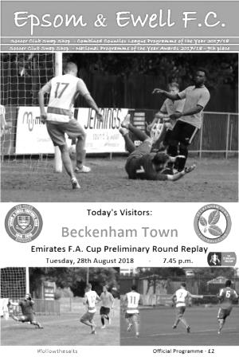
Salts run out of steam

Step Five Beckenham Town progressed to the next round of the Emirates F.A. Cup on Tuesday evening, but we made them work for it and it took 210 minutes before they were finally able to win through.

Our excellent performance on Saturday in earning a draw at Eden Park Avenue would prove to have been our best opportunity to progress as we were second best for the majority of this replay; the visitors spurning a number of opportunities to finish the tie inside the 90 minutes, while we struggled to find the space we were able to enjoy in the first match. Credit should also be given to our debutant keeper George Gill, who made his first team debut in relief of the suspended Ricky Borrett and made a number of saves with no handling errors either. It was cruel to him after such a fine performance that he would finally be beaten with a deflected shot.

The match had been in progress for no more than 30 seconds before a deflated football was replaced and the opening exchanges were a bit flat too, containing little of real note as both teams had clearly spotted areas to work on from the first tie and as a result cancelled each other out for large periods of the first half. In the third minute an Adam Heagney corner was met by a far post Kieran Campbell header which looped over the visiting keeper Michael McEntergart, but was cleared by a defender, while the visitors did not fashion a real chance until the 21st minute when Jamie Humphris was put through on goal but shot straight at Gill from 12 yards and our man made the save.

Our scorer from the first match Liam Roberts made a good run and low shot from the edge of the area on the half hour, but then was clattered into from behind just after the shot. The referee's whistle blew strongly and I thought we would see at least a card, yet after discussion the match restarted with a drop ball at the keeper's feet! It was one of a succession of puzzling decisions made on the night which left me lacking confidence and that the referee might make a serious error at some point later on. As I turned out, nothing major would occur on that front, although he ought to be reminded that the advantage law is actually there to help him too and it would have been nice to see that applied to what was already an attritional and scrappy opening half.

Some protection would have been nice too as the visitors clearly decided that Roberts should be denied the opportunity to make further runs, one way or another, and Jack Hope might not have stayed on the field on another occasion with a very late challenge on Roberts that a yellow card really didn't seem enough of a punishment for. Ironically Sean White then picked up a yellow card for a bit of a nudge in the back a few minutes later.

However, by this time we had found ourselves pushed back. Gill tipped over from a shot out on the left, while there were appeals for a free kick when a Beckenham shot beat Gill but was half cleared by Lloyd Connelly straight back to our keeper. Not sure if you can give a free kick for a deliberate forward pass to a goalkeeper, but this came close!

Gill was in action once again when a shot from distance looped up in a "Paul Parker Italia 90" type of fashion but Gill back pedalled to tip the ball over the bar although he could do nothing with a

low shot from twenty yards that pinged against his right hand post and away to safety six minutes before the interval. We had a few half chances with Steve Betancourt slicing a free kick wide after a foul on Scott Elgar; in for the absent Elliott Thompson, and a Heagney free kick was headed wide by Bobby Bennett from the edge of the area. In the 44th minute Connelly found himself in an advanced position and his left footed strike from the edge of the box stung the gloves of McEntergart, who gathered the ball at the second attempt.

The second half was less even as the visitors pressed further forward, yet still managed to keep us fairly quiet. Gill tipped over a far post header before Humphris blazed over from 12 yards and this became the pattern of the second half with chances either being saved by Gill or shot wildly over. Our keeper made arguably his best save of the night with a superb save from Humphris to his left after he had broken through on goal just before the hour. Changes were required and Taryn Smith entered the fray in place of Campbell who had been struggling with a back injury. This was more or less the formation that had caused the opposition so much trouble in the final half our in Kent, but no sooner had we settled into that shape, Elgar required replacement with Ben Dyson making his first appearance of the season, but this also moved Smith into the centre of midfield where he was unable to make the kind of runs that he had on Saturday.

As the game reached the final twenty minutes the pace appeared to slacken and it looked like we might have weathered the Beckenham storm. Chances were fewer until the final few minutes of normal time when the game got really stretched and chances came at both ends. Richard Atkins shot straight at Gill after he had broken our offside trap before Dyson fed Roberts but his shot was dragged across the face of the goal from 15 yards. Then they attacked again with Gill coming to the rescue once more before the whistle blew and extra time was signalled.

The extra period was delayed while the referee left the field. We are told that he was checking whether a fourth substitute could be allowed. The general consensus was that it would be, but apparently, it wasn't! With that matter sorted, they finally restarted the match with the visitors pressing once again. The goal when it finally came in the 99th minute from Jesse Darko was a low strike from around 20 yards that took a deflection off one of our players; the ball skidding past Gill before he could recover his position.

This was unfortunate to say the least, but it really had appeared for a while to be a matter of time before they broke through. We had a brief opportunity to respond when substitute Theo Campbell nearly marked his debut with a good run and low shot that was spilled before being recovered at the second attempt, but Beckenham had in fact got stronger with the introduction of Eku Dean who looked threatening in his time on the pitch and he capped his performance with a run across the box before hooking his shot back across Gill into the far corner in the 108th minute. The ball almost seemed to float across in slow motion, taking what seemed like ages before it hit the back of the net, but it was a great strike. A third goal followed seven minutes later after Josh Owen won a challenge in the middle of our half with Scott Murphy and went through to take the ball around Gill and roll the ball into the empty goal.

Our Captain was booked for complaining that he had been fouled and he may well have been right, but the damage had been done earlier and ultimately we just ran out of legs against a team that were solid, physical when required and dangerous up front. Maybe the real question here is how they were made to look so ordinary in the first match, particularly in the second half, and although we wish them well in the next round, it is likely that Step Three Walton Casuals will have far too much for them when they meet at Eden Park Avenue.

Epsom and Ewell: George Gill, Adam Heagney, Sean White, Lloyd Connelly, Steve Betancourt, Ryan Sullivan, Liam Roberts, Scott Murphy, Kieran Campbell, Scott Elgar, Bobby Bennett

Subs: Taryn Smith for Campbell (58), Ben Dyson for Elgar (65), Theo Campbell for White (102)

#
From behind the goal
Lingfield 6-1 Epsom & Ewell
Buildbase F.A. Vase - First Qualifying Round - Friday 31st August 2018

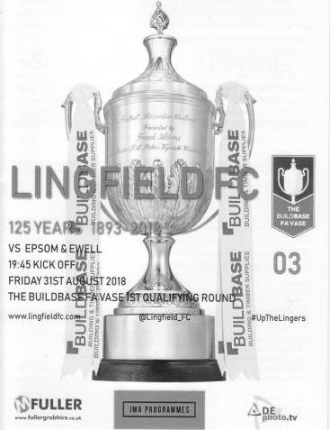
Salts not at the races

On a Friday evening at Whyteleafe FC the battle between two towns better known for a four-legged sport was a bit of a one-horse race as Lingfield cantered to an easy 6-1 victory and left our team as the joint first out of this year's competition.

This was always going to be a tough encounter. Playing in the division above us, albeit in the Sussex geographical area, Lingfield were expected to be of a similar standard to Langney Wanderers who we had edged past in the F.A. Cup. However, we were missing the injured Kieran Campbell and with a potential replacement in Taryn Smith absent too, the thankless task of playing in the number nine position fell to Bobby Bennett who has shown some nice work on the wings this season.

Sean White found himself in yet another different position, this time out on the right flank, while Steve Betancourt was also absent and Adam Heagney played in the centre, while Reisse Griffin returned at left back and Endrit Dobraj made his first appearance of the season at right back with Elliott Thompson returning to the line-up ahead of Scott Elgar, following his absence on Tuesday. Finally, George Gill retained the gloves after his fine display against Beckenham Town even though Ricky Borrett was now available. More surprising though was that Borrett didn't even make a five man substitutes bench. It was to be hoped that this decision not to play a reserve keeper wouldn't come back to bite us.

We had an early scare as Jake Connaris broke through in the seventh minute but dragged his shot wide. However, on the astroturf surface with the ball puffing up large clouds of black rubber every time it struck the ground, the home side looked very comfortable and began to stroke the ball around confidently. We did have a good chance on the quarter hour when White anticipated the bounce of the ball ahead of his defender and arrowed in on goal, his low drive being blocked to safety by the foot of keeper Olly Moore from inside the six yard box.

And five minutes later we were behind. Players got dragged into midfield to challenge for a header which was lost and the ball was played into space on the left. A deep ball to the far post was then squared low back into the danger area for Ben Connolly to finish the sort of chance that you or I might have been able to take from just three yards out.

Gill tipped over a long range shot soon after this, but the next five minutes would see our best football. Bennett fed Liam Roberts into a good position but his curling shot was just beyond the far top corner from 12 yards before White struck from an angle towards goal only to see Moore reach out and tip the ball away at full stretch for a corner.

It looked like we might equalise at this point but in the 29th minute disaster struck as a deep ball was headed back into the path of Connolly by a team mate and his low strike gave Gill no chance as it nestled in the far corner from 12 yards. We responded briefly as Griffin won a corner with a good run but the near post delivery from Roberts was sent over the bar by Lloyd Connelly and in the 36th minute it was more or less game over as Connolly completed his hat trick with another straight forward finish from a left wing delivery.

We were looking particularly vulnerable at the back in this match and appeared to be lacking the experience of a Betancourt or even an Alex McKay who was sitting on the bench throughout. Going forward though, we still threatened occasionally and a clever ball over the top of the defence from Scott Murphy resulted in White shooting at goal before heading in the loose ball after it had been half saved, only to see the flag raised for offside against him. White's performance was the only positive to take from a very disappointing first half.

Our Manager also clearly felt that changes were needed and Scott Elgar came on for Thompson who had struggled to get into this match, while at the back Dobraj found himself replaced by debutant David Jones; the fourth different player with that name to play for the club! However, the rout continued and in the 50th minute it was 4-0 as a right wing low cross was tapped in from close range by Jake Connaris.

In the 65th minute Connaris turned poacher and seized on a poor control by one of our defenders, lashing the loose ball past Gill on the volley from fairly close range and after 76 minutes it was 6-0 as Blake Pickett collected the ball outside the box and literally strolled past three men before smashing the ball straight through Gill's hands from ten yards out.

Lingfield looked like they may go on and score again, but there was to be only one more goal and it came at the other end. Griffin picked up the ball around the half way line and ran at goal before curling in a beauty from 20 yards that left Moore grasping at air as it flew into the top corner. It wasn't quite as impressive as his goal of the season in the Vase last year at Rusthall, nor was this goal as important, but it was still worth the admission money and to be fair, Epsom supporters had little else to cheer on the night. We nearly got another goal in the closing seconds after a Bennett header was sliced inches wide of his own goal by a defender, but it would have been irrelevant in the grand scheme of things and maybe we would be better off saving any good luck for the League campaign instead.

In summary this was a disappointing result and display, although we could point to the absence of some key players and 120 minutes of F.A. Cup action just three days previously, neither of which helped our cause. It has to be remembered that we will not play many teams like this in our Step Six campaign which we can now concentrate on with three matches coming up shortly in which we must try and catch up with the early pace-setters.

Ironically our next League match now looms large as we visit AC London next Wednesday. We should be able to find our way there easily enough though as they play at... Whyteleafe FC!

Epsom and Ewell: George Gill, Endrit Dobraj, Reisse Griffin, Adam Heagney,
Lloyd Connelly, Ryan Sullivan, Liam Roberts, Scott Murphy (c), Bobby Bennett,
Elliott Thompson, Sean White

Subs: Scott Elgar for Thompson (46), David Jones for Dobraj (46),
Theo Campbell for Sullivan (73)

This Day in History - 8th September
Date | Day | Competition |  | Opponents |  | Scorers
08/09/28 | Sat | London League | A | Millwall United | 1-1 | J.Parr
08/09/34 | Sat | London League | H | Grays Athletic | 1-0 | M.Wiggins
08/09/45 | Sat | F.A. Cup  Preliminary Round | H | Woking | 1-8 | G.Francis
08/09/51 | Sat | Corinthian League  Memorial Shield 1 | H | Edgware Town | 3-1 | T.Wright (3)
08/09/56 | Sat | F.A. Cup  Preliminary Round | H | Bexleyheath & Welling | 1-3 | D.Hermitage
08/09/62 | Sat | F.A. Cup 1q | H | Slough Town | 1-3 | B.Lambert
08/09/65 | Wed | Athenian League 2 | A | Croydon Amateurs | 0-3
08/09/79 | Sat | F.A. Trophy  Preliminary Round | A | Crawley Town | 2-0 | T.Tuite (2, 1 pen)
08/09/84 | Sat | Isthmian League  Premier Division | H | Walthamstow Avenue | 2-2 | T.Tuite, S.Hill
08/09/90 | Sat | Isthmian League 2s | H | Horsham | 1-3 | T.Tweedy
08/09/92 | Tue | Isthmian League Cup Preliminary Round | A | Thame United | 0-3
08/09/93 | Wed | Isthmian League Cup Preliminary Round | H | Hungerford Town | 1-0 | P.Meredith
08/09/98 | Tue | Isthmian League 3 | H | Flackwell Heath | 4-2 | J.Tome (4)
08/09/01 | Sat | Isthmian League 3 | A | Abingdon Town | 2-0 | S.Hatton (2)
08/09/07 | Sat | Combined Counties Premier Division | A | Egham Town | 1-1 | R.Burns
08/09/12 | Sat | F.A. Cup 1q | A | Bognor Regis Town | 0-4
08/09/15 | Tue | Combined Counties Premier Division | H | Colliers Wood United | 3-1 | K.Hough (2), D.Cooper-Smith
Historical Decades
90 years ago – Epsom Town F.C.
08/09/28 | Sat | London League | A | Millwall United | 1-1 | J.Parr
80 years ago – Epsom F.C.
07/09/38 | Wed | London League | A | Carshalton Athletic | 2-1 | B.Heal, o.g.
70 years ago – Epsom F.C.
04/09/48 | Sat | F.A. Cup Extra Preliminary Round | A | Dorking @ West Street | 3-0 | F.Chitty, T.Rochester, L.Gilbert
60 years ago – Epsom F.C.
09/09/58 | Tue | Southern Combination Cup 1 | H | Uxbridge | 3-0 | D.Hermitage, B.Smith, o.g.
50 years ago – Epsom & Ewell F.C.
07/09/68 | Sat | Athenian League 2 | H | Aveley | 1-2 | K.Jolly
40 years ago – Epsom & Ewell F.C.
09/09/78 | Sat | F.A. Trophy  Preliminary Round | H | Hounslow | 1-1 | A.Hill
30 years ago – Epsom & Ewell F.C.
07/09/88 | Wed | Isthmian League 2s | A | Molesey | 1-3 | N.Robson
20 years ago – Epsom & Ewell F.C.
08/09/98 | Tue | Isthmian League 3 | H | Flackwell Heath | 4-2 | J.Tome (4)
10 years ago – Epsom & Ewell F.C.
06/09/08 | Sat | F.A. Vase 1q | H | Colliers Wood United | 4-2 | L.White (2), J.Keys, K.Hough

History Corner – 8th September
90 years ago today we visited the Locke’s Sports Ground for a London League match with Millwall United who were no connection to the larger, better known club. In fact, unlike that club who play in New Cross, this team were actually based North of the River Thames and actually in the Millwall area, at Westferry Road. However, this team was struggling after a few years in the League and although a Jack Parr goal secured us a 1-1 draw in this match, they never finished the season, folding midway through December after playing just five matches.

73 years ago today we played our first match for six years against Woking in the F.A. Cup. Although the closely associated Epsom Town had played throughout World War Two, the main Epsom club had closed down in September of 1939 and although the ground had probably been kept in a better state than some places which were left derelict, the team really was a scratch outfit and were battered 8-1 by their Isthmian League neighbours. One high point this day was the debut of local lad Ernie Watkins who would go on to play for fifteen more years, making over 400 appearances. When he left for Banstead Athletic after apparently being surplus to requirements, he served them for another eight seasons, finally retiring in 1968 at the age of 47!

67 years ago today we hosted Edgware Town in the Corinthian League Memorial Shield. This was the equivalent of their League Cup and had been dedicated to the crew of an airplane that had been shot down during the War. On this occasion it was our right winger Tommy Wright who was doing the shooting and he scored a hat trick as we progressed 3-1, eventually reaching the Final for the first time and losing to double winning Hounslow in front of 5,000 at Eastbourne.

60 years ago this week we welcomed Uxbridge to West Street for our first ever match in a new competition, the Southern Combination Cup. Yes, it really has been around that long! Goals from Dave Hermitage and Bernard Smith, together with an own goal gave us an easy 3-0 win.

40 years ago this week we had a collectors item; one of only three goals scored by central defender and of course, future Manager Adrian Hill as we drew at home to Hounslow in the F.A. Trophy. We would follow this up by winning the replay 1-0 at Denbigh Road, although the run ended at Isthmian League leading Croydon, one of Hill’s former clubs that he would also go on to Manage, who defeated us 5-0.

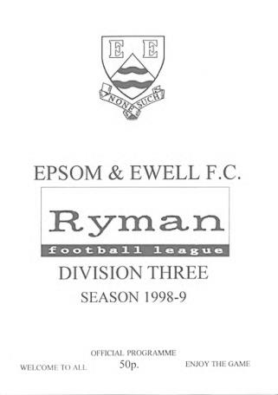
20 years ago today we won our fourth straight Isthmian League match of the season when defeating Flackwell Heath 4-2 at Merland Rise, even though the visitors scored first and last in the match. (see programme left) The encounter was a personal triumph for Joao Tome who scored all of our goals; a feat matched by Daryl Cooper-Smith at Worcester Park in 2016 but never exceeded since. Despite this record we still weren’t top as Wingate & Finchley had played a game more and had an extra point. We would have to wait until 2002 before we sat on top of a league table, which would be the first time since 1981.

Centre page for results

Centre page for results

Cove F.C. – History
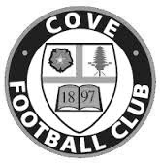
Cove F.C. were formed in 1897 by a group of local people playing on a field behind their favourite Public House.
Moving to a more central location, Cove Green became their home until 1973, when they moved to their present ground at Oak Farm. Playing their football in The Surrey Leagues, Cove enjoyed success for many years, winning more than their fair share of silverware in this time, including the League Championship three years in succession and a double.

In 1973, the club decided to upgrade and were accepted into the Hampshire Leagues, but had to leave 'The Green' for safety reasons. The Division 4 Championship was won at the first attempt, and the Division 3 title followed 2 years later. After a couple of seasons, Cove finished Runners-Up in Division 2, but decided to withdraw from this league due to the time taken to away matches in Portsmouth or Southampton, before the M3 motorway was built.

Thus they returned to the more local Combined Counties League in 1980, and won the League Cup beating close neighbours and rivals Ash United. Since moving into their new home, many changes have taken place at Oak Farm with the installation of floodlights a concrete perimeter wall and stand in their quest to house senior non-league football. These achievements are the more remarkable with Farnborough Town (then Conference League) and Aldershot Town (then Football League) just a couple of miles down the road.

In 1990, Cove were given the chance to join the Isthmian League after finishing third. New manager ‘Chick’ Botley assembled a squad strong enough to finish a respectable fourth in their first season. Two more successful seasons followed narrowly missing out on promotion, once a final day defeat by the new Aldershot Town. Due to the ever spiralling cost of football at this level, Cove were forced to withdraw and had to revert back into The Combined Counties League, where they remained with little success.

Due to the ever spiralling cost of football at this level, Cove were forced to withdraw from their league and after 3 unsuccessful attempts to join the Wessex League, had to revert back into The Combined Counties League, where they remained with little success. In 2009, the club appointed Koo Dumbuya as manager and a member of the Steve Beeks double winning team and well known around the area. Having played professional football for Aldershot and Brentford, the club decided his playing experience and knowledge could be invaluable and in his first season, Cove won the Southern Combination Cup with a 4-0 victory over Chessington and Hook.

In Season 2010-11, Cove won the Combined Counties League Cup with a 2-0 win over Bedfont, followed by a victory over Farnborough Town in the semi-final of the Aldershot Senior Cup before losing to Fleet Town in the final. In 2011 manager Koo Dumbuya left the club after 4 years as player and manager to take up a post at Chertsey Town, leaving a big hole to fill as his knowledge of local football is immense. The task of filling this hole was left to his assistants Paul Duncan and Simon Brand to rebuild the team from new as 9 players left at the end of the previous season. On a happier note, President and old player, Frank Kenton, and Secretary Graham Brown both received an award from Hampshire FA for 25 years service.

In 2011 manager Koo Dumbuya left the club after 4 years as player/manager to take up a post at Chertsey Town, leaving a big hole to fill as his knowledge of local football was immense.

During season 2012-13 following some poor performances, the club employed an ex-player Anthony Millerick who brought instant success with the winning of the Aldershot Senior Cup and a 3-0 victory over Fleet Spurs, also finishing 3rd in the League, our highest position for many a year.

2013-2014 was another successful season finishing 5th after a run of 22 games, 19 wins and 1 defeat and 2 draws.

2014-2015 was yet another very successful year sitting on top of the league for half the season, but unable to go for promotion due to the cost of ground improvements and travel, saw a considerable dip in form, leaving Cove with a fifth-place finish and a mass exodus of management and players.

A complete change of personnel followed with the appointment of Dave Matthews as manager, following his success as a Youth Team coach. He accepted the challenge of building a new team capable of retaining their position in the Premier Division. However, our young team of hopefuls were unable to compete at this level and after some poor results found ourselves at the foot of the table many points adrift of safety, Following the resignation of Dave at Christmas, new manager Paul Duncan set about trying to save our Premier status, but despite some improved performances the points difference right at the bottom was too much and hence we found ourselves relegated to the CCFL Division One. This is the first time in the clubs 120 year history that Cove was faced with relegation.

In the summer of 2016 Cove desperately needed a change; both in personnel responsible for the club overall and football strategy going forward. It also needed a huge amount of work to the clubhouse and grounds. The whole place needed an overhaul. The result was several resignations from the old committee and new ideas and aspirations from many in the Youth setup and new Chairman Salvatore Diprima.

The club structure has changed and focus is on building a new senior side ably supported by new Under 18 and Under 21 football sides. The future is to have a thriving family club including all 20 plus youth teams and parents, walking football and local sponsors. This 2016-17 season has been very difficult so far but improvements are everywhere as Salvatore builds a new team and club. The journey will be a long one to return to previous successes but we are determined to get there.

A special mention to Ron Brown, who in 1990 received an F.A. Award for 50 years’ service to Cove FC, including 35 years as secretary. Ron retired in 1982 passing the reins to his son Graham. Sadly Ron passed away in 2009 after 70 years’ service including 20 years as Club President.

So we have seen a lot and been through a lot over the years and with a new executive committee and some new committee members, we are eagerly moving forward, with new and exciting developments to the clubhouse and the surrounding grounds, we are very excited for the times ahead, while not losing sight of the clubs long and proud history, something that is on show within the clubhouse, new developments to the Club kitchen and changing rooms, as well as the executive boardroom and clubhouse. We look forward to seeing you there, sharing in the new success.

Happy Birthday to Our Club President!
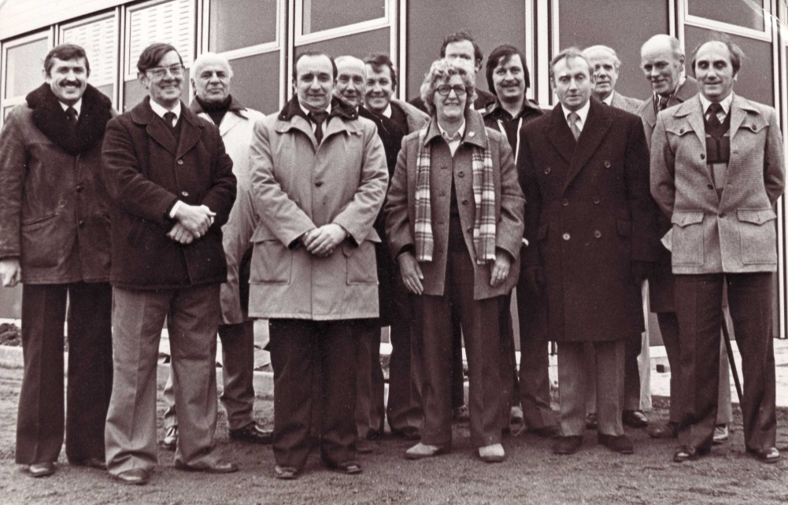

Stella and many other club officials stand outside the newly opened clubhouse in 1980

On 1st September 1928, not many weeks after our club had won the London League, our Club President Stella Lamont was born.

Her interest in football can be traced back to the 1950s when she would stand on the terraces at Millwall or attend games at Dulwich Hamlet, close to where she lived in London, although it was at Dulwich Hamlet; giants of the Amateur game throughout the first half of the 20th Century that Stella came to prefer non-league football to its professional counterpart. In Stella’s words “I came to value the special kind of camaraderie that is synonymous with lower league football – not just within clubs but between them too”.

In the Sixties Stella was a founder member of Grove F.C. who were members of the Epsom & Ewell Youth League that had been formed back in 1944/45. In the Seventies her son began playing for that club and she also became a League official, twice travelling to California as part-organiser of a football and cultural exchange.

Stella took a regular interest in our club from 1973, becoming Press Secretary and also Programme Editor from 1979-2008 alongside Dave Wilson. I realised when taking on the Editor position that I had a hard act to follow, as those programmes were always of a high quality with plenty of information; something I have tried to continue since.

Stella recalled that: “During my years since 1979 as Epsom’s Programme Editor I have spent many a pleasant hour preparing special editions for Christmas and other festive occasions just by adding a few pictorial touches. This was a real paste-up task and would take quite a few hours, especially when there was no luxury of using professional printers. Things were often made harder by the breakdown of the photocopier, but still

Stella lines up with our team in 2008 on the occasion of her eightieth birthday

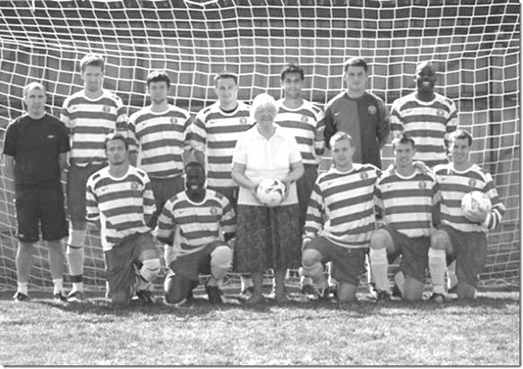
the effort was worthwhile. Now of course we not only rely on the professional printers, but use computers instead of typewriters.”

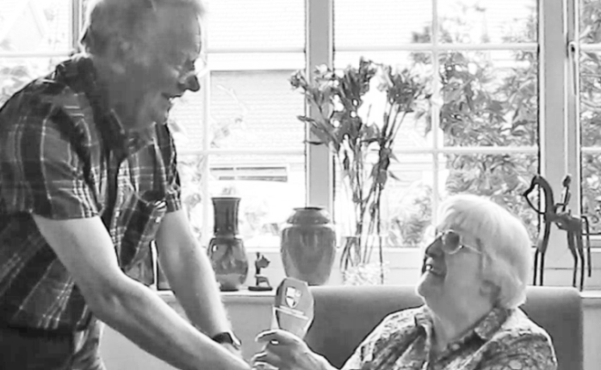
This wasn’t the extent of Stella’s involvement. For around thirty years she saw almost every Epsom game both home and away, which she thoroughly loved doing until her health became too problematic to attend matches at all and her last matches attended were at Merland Rise, (by which time she was Membership Secretary) before we left for Merstham and subsequently Chipstead.

In the summer of 2016 she received a long service award from the Surrey F.A. in recognition of fifty years of involvement in youth and county football. (see picture right)

Stella is pictured back in 2008 with Club Captain Alex Rodrigues and Vice-Captain Jamie Hatfield as they modelled their new kit from Allams Alfa Romeo in Epsom

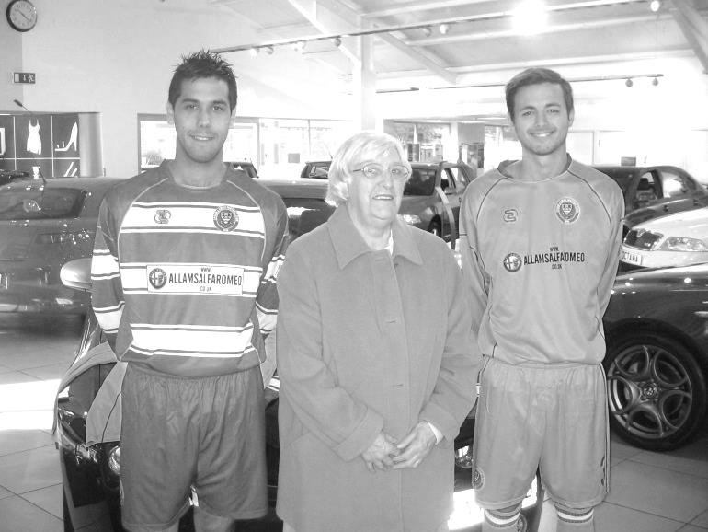
In addition to these achievements, what many of you may not be aware of is that Stella also inadvertently became part of a pop music video!! In 1992 and not long before we left West Street in 1993 a South London band, I Ludicrous, produced a video to accompany a new song of theirs, We Stand Around. It was apparently described as “The best football song ever”.

One of the band members John Proctor was born in Epsom in 1957 and went to Glyn School, spending time down the road at West Street in his formative years. He explained to me that although he was a Crystal Palace fan, he wanted to go back to Epsom to get some footage for the song because it was more authentic, and also because we’d be leaving soon so he could visit one more time. The footage appears to have been from a match against Horsham in 1990 and a portion of it was taken from the stand, which you can clearly see Stella exiting at the end of the match!

The images are too grainy for this programme, but the whole video is available at our website in the Previous Articles section. Just scroll down a little way and it is on the left.

Stella remains a keen supporter of the club and of course still contributes in these pages from time to time. Happy Birthday Stella from all of us at the club!

Our Chairman Pete Beddoe also has a few words to say about our President.

"This beautiful cover photo of Stella, taken on her 90th birthday, epitomises perfectly her personality; calm and relaxed.

I've known Stella since the early 1980s and still can visualise her ensconced in her favourite position in the wooden stand at West Street.

She was always very welcoming to all new supporters and in my case someone whose support she rekindled. Over the years she has provided invaluable service on the Club Committee with such duties as Membership Secretary, Press Secretary and Editor of the programme.

Stella still involves herself in the day to day affairs of the Club, encouraging our Manager and is always available to provide advice which is invaluable - long may this continue.

With all our love and wishing a Happy Birthday on behalf of the Club, Peter."

EL Records Division One Challenge Cup
First Round
Farnham Town | V | Godalming Town
Cove | V | British Airways
FC Deportivo Galicia | V | AC London
Second Round
Eversley & California | V | Bedfont & Feltham
Epsom & Ewell | V | Sandhurst Town
Tooting Bec | V | Ash United
Kensington Borough | V | FC Deportivo Galicia / AC London
Sheerwater | V | Chessington & Hook United
Fleet Spurs | V | Cove / British Airways
Dorking Wanderers | V | Frimley Green
Farnham Town /  Godalming Town | V | Bagshot

EL Records Premier Challenge Cup
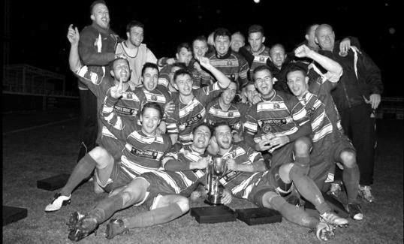
First Round
Camberley Town | 18/9 | Cobham
Horley Town | 18/9 | Chertsey Town
Badshot Lea | 25/9 | Walton & Hersham
FC Deportivo Galicia | 12/9 | Cove
Chessington & Hook United | 18/9 | AFC Hayes
Farnham Town | 18/9 | Southall
Hanworth Villa | 18/9 | Kensington Borough
Second Round
Bedfont & Feltham | 25/9 | Tooting Bec
Sheerwater | 18/9 | Balham
Ash United | 2-3 | Fleet Spurs
Frimley Green | 25/9 | Guildford City
Godalming Town | 25/9 | Dorking Wanderers Reserves
Abbey Rangers | 25/9 | Redhill
FC Deportivo Galicia / Cove | V | AC London
Camberley Town / Cobham | V | Chessington & Hook / AFC Hayes
CB Hounslow United | V | Badshot Lea / Walton & Hersham
Hanworth Villa / Kensington Borough | V | Sandhurst Town
Epsom & Ewell | 25/9 | Bagshot
Sutton Common Rovers | V | Farnham Town / Southall
Horley Town / Chertsey Town | V | British Airways
Eversley & California | 25/9 | Knaphill
Banstead Athletic | 25/9 | Colliers Wood United
Spelthorne Sports | 25/9 | Raynes Park Vale

Match and Ball Sponsorships – 2018/19
Opponent | Date | Match Sponsor | Ball Sponsor
Chessington & Hook Utd | 21/08/18 | Club President - Stella Lamont
Beckenham Town (FAC) | 28/08/18 | Building Shop Ltd
Cove | 08/09/18 | EEFC Management Committee
Tooting Bec | 18/09/18
Bagshot (LC) | 25/09/18
Sheerwater | 06/10/18
Knaphill U23  (Surrey Premier Cup) | 23/10/18
Frimley Green | 03/11/18
Kensington Borough | 17/11/18
Dorking Wanderers Res | 27/11/18
Godalming Town | 01/12/18
Bedfont & Feltham | 08/12/18
Eversley & California | 29/12/18
Ash United | 12/01/19
Bagshot | 19/01/19
Farnham Town | 02/02/19
British Airways | 16/02/19
AC London | 02/03/19
FC Deportivo Galicia | 12/03/19
Fleet Spurs | 06/04/19
Sandhurst Town | 20/04/19 | Club President - Stella Lamont
Sandhurst Town (LD1C) | tba
Match sponsorship costs just £60.00!

Sponsorship includes:

Admission, programmes and hospitality for three people.

A full page advert in the programme and mascot for the day (if required).

If you are interested, just speak to a Committee Member,
or drop me an email at: richard.c.lambert@gmail.com

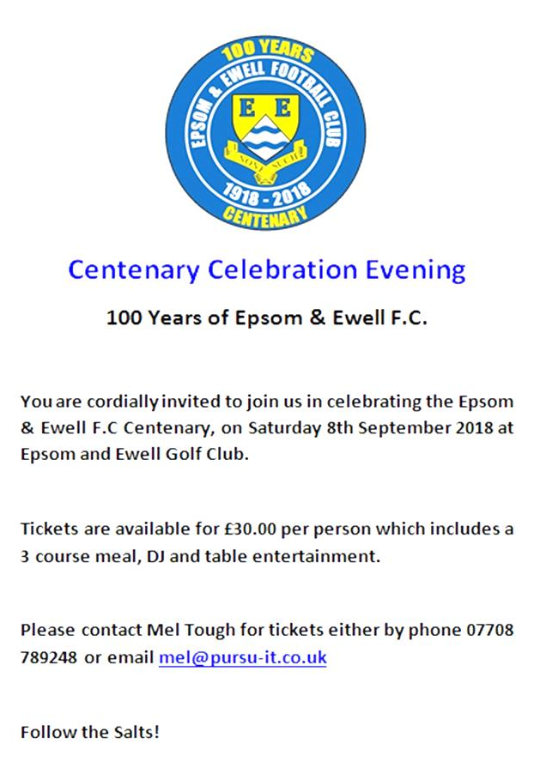

Combined Counties League – Division One
Saturday, 8th September 2018 - Kick-off 3.00 p.m.
Epsom and Ewell  (Royal Blue & White hoops) | V |  | Cove  (Yellow / Black / Black)
Squad | NUMBERS |  | Squad
Ricky Borrett |  |  | Conor Allison
Adam Heagney |  |  | James Allison
Sean White |  |  | Riccardo Andrady
Lloyd Connelly |  |  | Kenneth Attafuah
Steve Betancourt |  |  | Louis Bishop
Ryan Sullivan |  |  | Terry Brooks
Liam Roberts |  |  | Luke Cooper
© Scott Murphy |  |  | Louis Elmer
Kieran Campbell |  |  | Michael Flounders
Elliott Thompson |  |  | Kai Francis
Bobby Bennett |  |  | Paras Gill
Reisse Griffin |  |  | George Hedley
Taryn Smith |  |  | Josh Howard
Mitch Sutherland |  |  | Daniel Hutchings
Alex McKay |  |  | Wat Jones
Luke Elgar |  |  | James Kelly
Ben Dyson |  |  | Sam Lynam
Endrit Dobraj |  |  | David Lynn
Stuart Russell |  |  | Josh Moody
Jay Bateman |  |  | Attila Nemeth
Louis O’Brien |  |  | Aaron Seymour
George Gill |  |  | Josh Taylor
Shaun Masterson |  |  | Joel Sinclair
 |  |  | Djeny Tudila
 |  |  | Aiden Upward
 |  |  | Taylor Watts
Neil Grant | MANAGER |  | Josh Taylor
Simon Funnell | ASSISTANT
Sam Morgan / Alex McKay | COACHES |  | Tony Millstead
REFEREE: K.Parker
ASSISTANTS: M.Stevens, M.Lewin
Today’s Match and Match Ball are sponsored by:
The Epsom & Ewell FC Management Committee

OUR NEXT VISITORS TO HIGH ROAD
Tooting Bec
Cherry Red Combined Counties League – Division One
Tuesday, 18th September 2018

